MODEL CONTEXT PROTOCOL

What is Model Context Protocol?
MCP is an open-source protocol that defines how AI applications can connect to external systems in a uniform way.
Example:
Consider it the "USB-C port for AI": MCP offers a universal connector for AI programs to connect to external data, tools, and workflows, much like USB-C offers a common plug for devices (laptops, chargers, and headphones).

Why MCP?
Every AI integration is custom-built in the absence of MCP. For instance:
- One integration would be required in order to access a database.
- Another is to retrieve data.
- Another to run a calculator.
MCP eliminates the requirement for one-time integrations by allowing AI applications to communicate with any MCP-compliant system by simply understanding the MCP standard.

What MCP Connects To?
- Data sources: local files, knowledge bases, SQL/NoSQL databases, and APIs.
- Tools: Web browsers, code interpreters, calculators, and search engines.
- Workflows: Ticketing systems, corporate procedures, and customized fast pipelines.

MCP: End-to-End Workflow
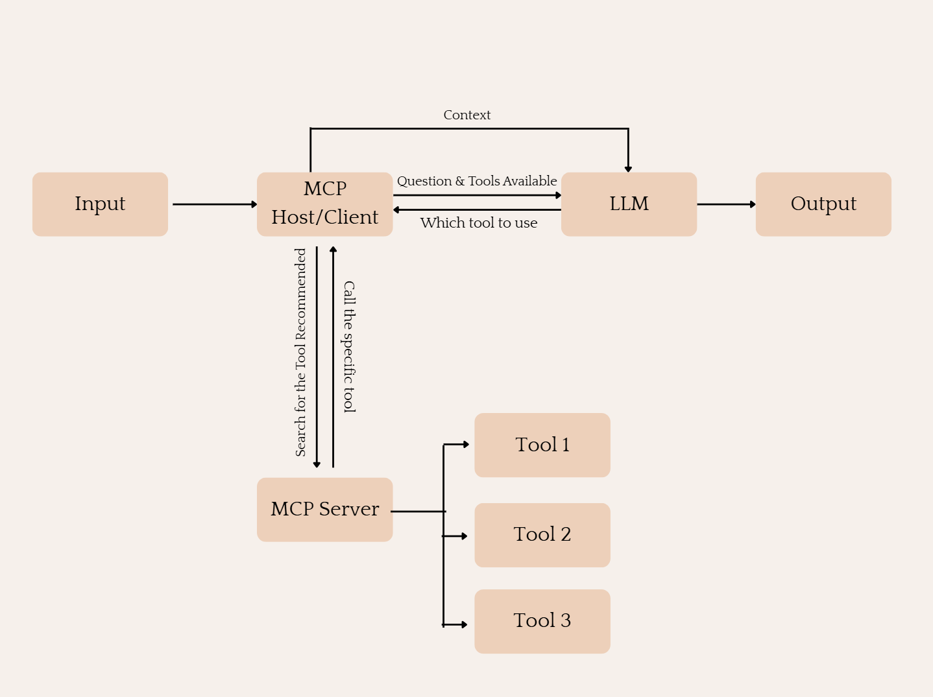

ServiceNow MCP:
Model Context Protocol (MCP) is an open, standardized communication layer that connects AI models with external tools and services. It enables seamless, tool-augmented reasoning by allowing AI Agents to dynamically discover and invoke tools based on the user's query.
In ServiceNow, MCP does not imply a proprietary “hosted server” owned by ServiceNow. Instead, ServiceNow provides the client-side implementation (MCP Client) inside AI Agent Studio, which can connect to any MCP-compliant external MCP Server

MCP Client (Provided by ServiceNow)
- Exists within AI Agent Studio.
- Registers a custom MCP Server using:
- OAuth 2.1, API Key, or manual credentials.
- Allows AI agents to:
- Discover tools.
- Send execution requests.
- Fetch metadata about tools.

Building a Custom MCP Server
1. Select a Web Framework
Begin by choosing a backend framework suitable for building REST APIs. You can use frameworks like:
- FastAPI or Flask in Python
- Express in Node.js
- Spring Boot in Java
- Gin in Go
The framework will help you define endpoints, handle requests/responses, and manage tool logic cleanly.

2. Design a Tool Registry Endpoint
This is the primary endpoint that returns a list of tools your MCP server supports. The registry provides:
- Tool names
- Descriptions
- Required input parameters
- Output format
This allows any MCP client (like ServiceNow or Claude) to discover what tools are available.

3. Define Tool Execution Endpoints
For each tool listed in your registry, create a unique endpoint that can:
- Accept structured input (usually JSON with parameters)
- Run the tool’s logic or connect to an external service
- Return the result in a predefined format
Each execution endpoint should follow a consistent naming pattern and structure, making it easy for AI clients to call them.

4. Structure Input and Output Contracts
To be compliant with MCP protocols:
- Inputs should be accepted as JSON objects under a common key (like parameters)
- Outputs must be returned as JSON with a standard field (e.g., result or output)
Following a consistent schema ensures the MCP client can parse responses and take appropriate action.

5. Host the MCP Server Publicly
Your MCP Server must be accessible to any external system or agent, so you must:
- Host it using a cloud provider like AWS, Azure, Render, Heroku, or GCP
- Ensure it's exposed over HTTPS
- Obtain a stable URL (e.g., https://yourmcpserver.com) for configuration in platforms like ServiceNow

6. Implement Authentication (Optional but Recommended)
To secure access to your tools:
- Use API key headers for simple authentication
- Use OAuth 2.1 for enterprise integrations (required by platforms like ServiceNow)
- Implement rate limiting, access logging, and validation checks for production environments

7. Maintain Tool Metadata
Your MCP server should allow the tools to be easily updated, added, or disabled. Maintain tool metadata in:
- A static config file
- A database
- An in-memory structure
This helps in managing dynamic tool availability without server restarts.

8. Test and Document Your Tools
Ensure each tool endpoint:
- Handles errors gracefully
- Validates input schema
- Provides meaningful output messages
Prepare a Swagger/OpenAPI spec or basic API documentation to make it easier for consumers (like ServiceNow MCP Client) to integrate and troubleshoot.

